Nightscout for Alexa Skill

**This outline assumes that you have basic experience with AWS and Python 2.7**

1. First of all, we need to create an AWS account. You can do that [here](https://aws.amazon.com/).
   1. You should be able to stay in the free tier, but you will have to put in a payment method
2. Now go to developer.amazon.com, sign in with you AWS credentials, and hit Alexa
   1. 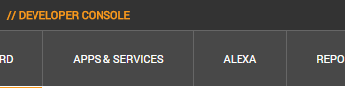
   2. Then click “Alexa Skills Kit” / Get started
      1. 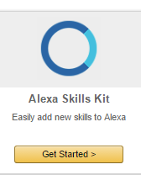
3. On the next page, press “Add a New Skill”
4. Fill out the page as follow:
   1. 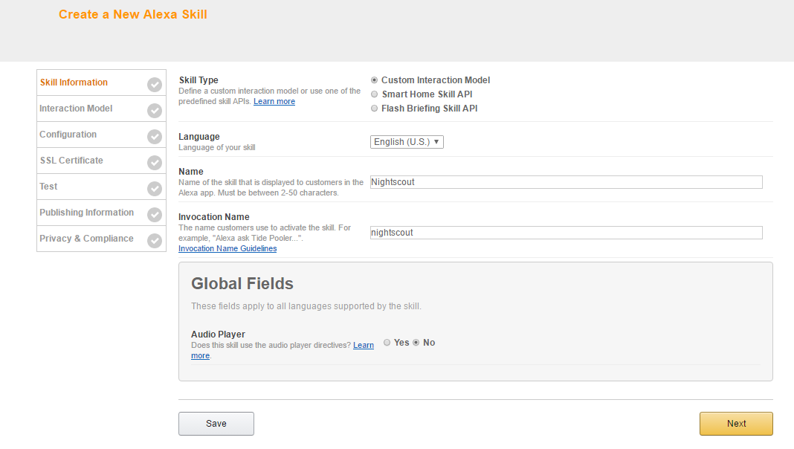
   2. For Skill Type put Custom Interaction Model, set the language to English
   3. For name, set the skill to what you want it named
   4. For Invocation Name, set it to what you want to say to Alexa
      1. e.g. “Hey Alexa. Tell [invocation name] to [get data from nightscout]”
   5. Set Audio Player to NO and press Next
5. You will see a few things. Take note of the address at the top
   1. 
   2. For Intent Schema, paste the contents of Intent Schema.json from the repository into the box
      1. 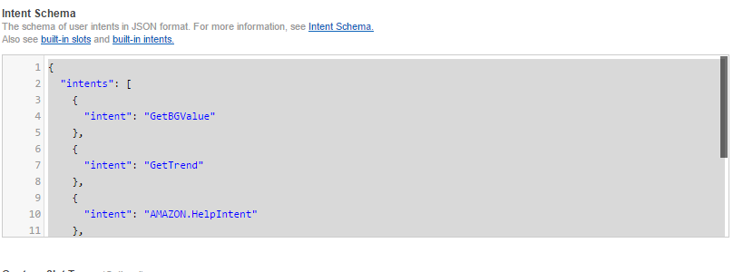
   3. For Sample Utterances, paste the contents of Sample Utterances.txt from the repository
      1. 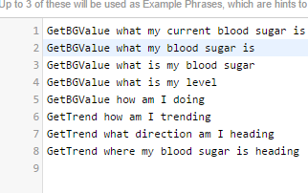
6. Press next
7. Set the Endpoint to AWS Lambda ARN and tick North America
8. Now we have to go to <https://console.aws.amazon.com/>
   1. ***MAKE SURE YOU ARE NORTH VIRGINA MODE OR THIS WILL NOT WORK!!!!!***
   2. 
   3. 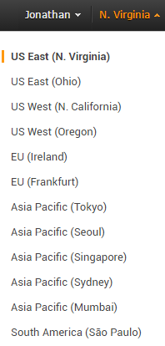
   4. Click N. Virginia to switch
9. Then search for Lambda in the search bar
   1. 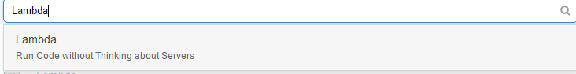
   2. Click Lambda
10. Press create a Lambda function
    1. 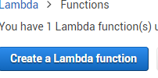
11. Type “alexa” in the blueprint search bar’
    1. 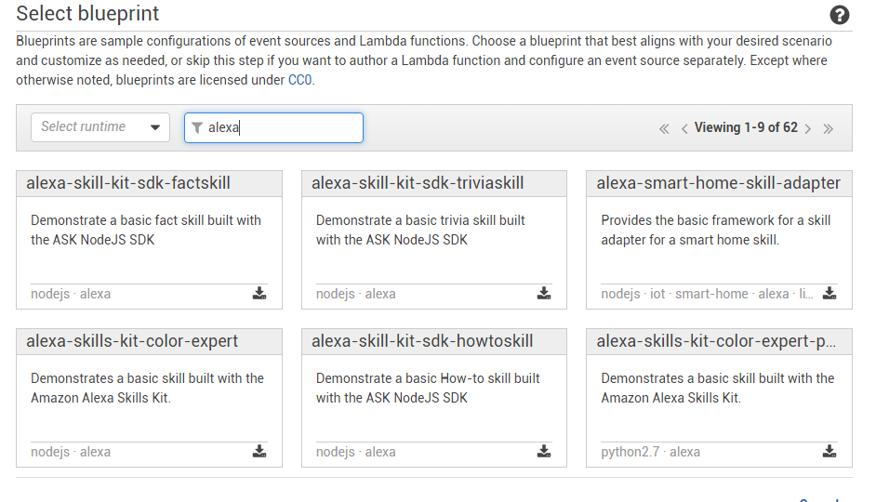
    2. Click the one highlighted in the picture above
12. Press next and next on the page after that
13. Now fill out as follows:
    1. 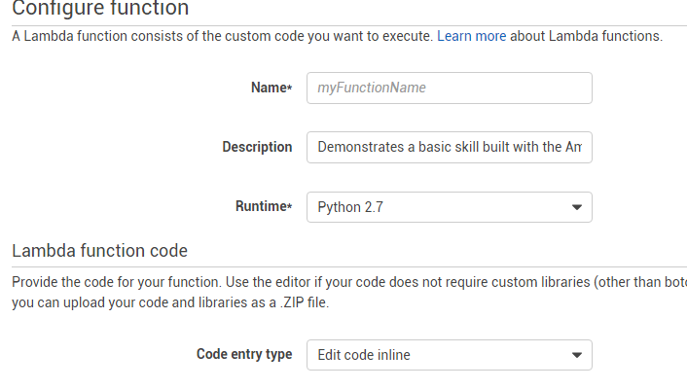
    2. For Name, name it whatever you want
       1. Ditto for description
    3. Keep the Runtime as Python 2.7
14. For code entry type, click Upload a .ZIP file
15. If you haven’t already, please download the repository from GitHub.
    1. You will have to make a few changes to the lamda_function.py file
16. Edit the lamda_function.py file
    1. 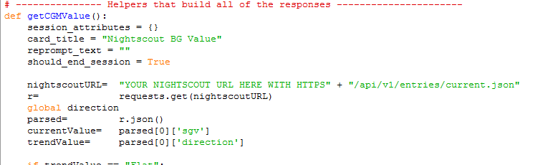
    2. Add your Nightscout URL in all the places the file asks for it
    3. If you wish, feel free to customize the messages that Alexa will speak
    4. Add your Application ID that we noted in step 5 here
       1. 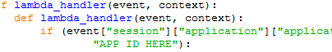
17. Save the file and zip it with the two folders with requests in the title
    * 1. 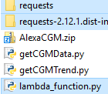
18. Go back to the Lambda page and upload that zip file
    * 1. 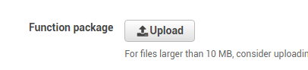
19. Oh, and set the role on the page to some random name. We don’t need it, but we have to fill something out to continue.
20. Press next
21. Hit create function
22. This should you bring to the Lambda dashboard
23. Copy this ARN
    * 1. 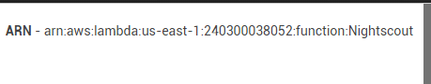
    1. Paste it into the Skills Page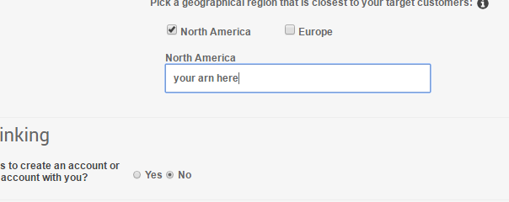
24. Press Next and test if you want
25. Skip to privacy and compliance by clicking on the check mark
    1. 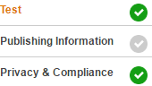
26. Fill out that crap
27. Assuming you did everything right, it should be working!
    1. PM me if you have any questions